SIMATS ENGINEERING

ASSESSMENT TOOL 1

COURSE NAME: INTERNET PROGRAMMING COURSE CODE: CSA43

COURSE OUTCOME COVERED

CO-1 : Develop well-structured, standards-compliant web pages using HTML/XHTML and XML, and apply Internet protocols and HTTP communication mechanisms for web content delivery. (L2)

Assessment Tool : Application-Based Questions

Weightage: 40%

QUESTIONS: Total Marks: 30

1: Online Symposium Portal
A college is developing an online symposium registration portal. The following HTML structure and HTTP interaction is observed:
<form action="/register" method="POST">
<input type="text" name="name">
<input type="email" name="email">
<button>Submit</button>
</form>
When a student submits the form, the browser sends an HTTP request to the server, and the server responds accordingly.

Questions:

- Identify appropriate HTML5 semantic elements missing in the structure.
- Modify the structure to make it standards-compliant.
- Interpret the HTTP request generated during form submission.
- Analyze the HTTP response cycle from server to browser.
- Suggest improvements for usability and accessibility.

2: Cross-Browser Compatibility Issue
A company website shows inconsistent layout across browsers. The following HTML snippet is used:
<html>
<head>
<title>Company</title>
</head>
<body>
<div>
<h1>Welcome
<p>About us
</div>
</body>
</html>

Questions:

- Identify improper nesting and missing closing tags.
- Analyze how different browsers may interpret this structure.
- Identify missing semantic elements (e.g., header, section).
- Provide a corrected W3C-compliant HTML structure.
- Suggest techniques to ensure cross-browser compatibility.

3: Form Submission Failure
A web application fails to send form data to the server. The following configuration is observed:
<form action="/submit" method="GET">
<input type="text" name="username">
<input type="password" name="password">
<button type="button">Login</button>
</form>

Questions:

- Identify issues in the form configuration.
- Analyze why the HTTP request is not triggered.
- Interpret the role of GET method in this scenario.
- Propose a corrected implementation.
- Suggest improvements for secure data transmission.

Code of Conduct:

I K.Reddy Srija(192372365) (Name / Reg No) certify that this submission is my original work and that I have adhered to the guidelines specified for this assessment. I understand that any violation of academic integrity rules will result in disciplinary action.

Signature of the student:
K.Reddy Srija

ANSWERS:

Question 1: Online Symposium Portal

1. Identify appropriate HTML5 semantic elements missing in the structure.

The given HTML form lacks proper document structure and semantic elements. The following HTML5 elements can improve its organization:

<header> – Defines the heading of the symposium portal.

<main> – Contains the main content of the webpage.

<section> – Groups the registration form under a meaningful heading.

<footer> – Contains copyright or contact information.

<label> – Provides accessible labels for form inputs.

2. Modify the structure to make it standards-compliant.

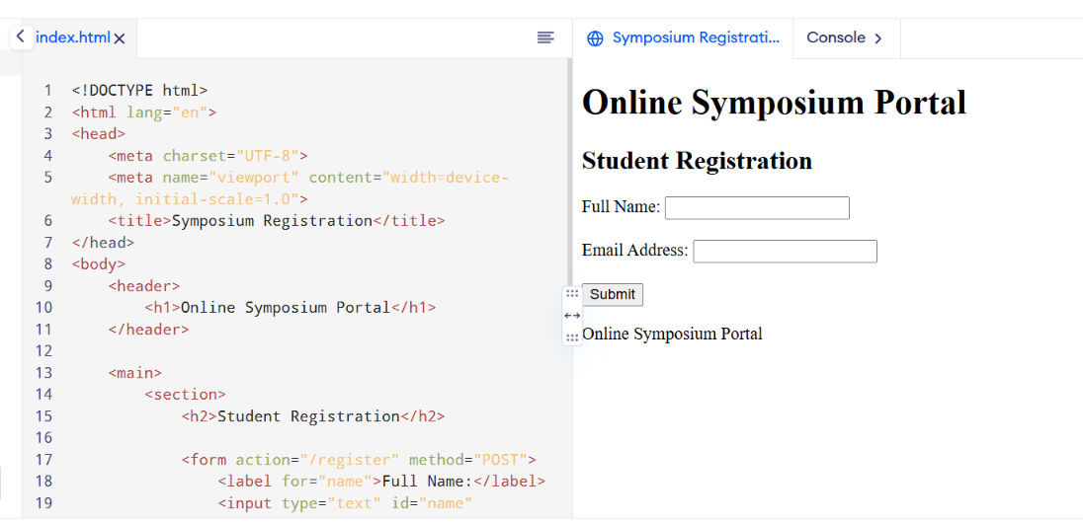

3. Interpret the HTTP request generated during form submission.

When the student submits the form, the browser generates an HTTP POST request to the /register endpoint.

Example:

POST /register HTTP/1.1

Host: example.com

Content-Type: application/x-www-form-urlencoded

name=Kavya&email=kavya%40example.com

POST: Sends form data in the request body.

Host: Identifies the destination server.

Content-Type: Specifies the format of the submitted data.

Request body: Contains the student's name and email address.

4. Analyze the HTTP response cycle from server to browser.

The browser validates the required form fields.

The browser sends the HTTP POST request to the server.

The server receives and processes the registration data.

The server validates the submitted information and stores it if appropriate.

The server sends an HTTP response containing a status code and possibly an HTML page or redirect.

The browser displays the registration result to the student.

Example response:

HTTP/1.1 200 OK

Content-Type: text/html; charset=UTF-8

The status code 200 OK indicates that the request was successfully processed. A 201 Created response may be used when a new registration resource is created.

5. Suggest improvements for usability and accessibility.

Add labels to all input fields.

Use the required attribute for mandatory fields.

Use type="email" for email validation.

Provide clear error messages and submission confirmation.

Ensure sufficient color contrast and readable font sizes.

Support keyboard navigation and screen readers.

Use HTTPS to protect data during transmission.

Question 2: Cross-Browser Compatibility Issue

1. Identify improper nesting and missing closing tags.

The given HTML contains the following problems:

The <h1> element is not explicitly closed.

The <p> element is not explicitly closed.

The document is missing the <!DOCTYPE html> declaration.

The <html> element does not specify the document language.

The webpage lacks semantic structural elements such as <header>, <main>, and <section>.

These errors can cause browsers to interpret the document differently.

2. Analyze how different browsers may interpret this structure.

Browsers use HTML parsing rules to construct the Document Object Model (DOM) from HTML source.

Some browsers may automatically insert missing closing tags.

Browsers may construct a DOM that differs from the developer's intended structure.

Layout and spacing may appear inconsistent because of browser defaults.

Older browsers or strict validation tools may expose compatibility problems.

Missing a DOCTYPE may trigger quirks mode, potentially changing layout behavior.

Therefore, explicitly closing elements and following HTML standards improves consistency.

3. Identify missing semantic elements.

The following semantic elements should be used:

<header> – Contains the page heading.

<main> – Identifies the primary content.

<section> – Groups related information.

<footer> – Contains footer information.

These elements improve accessibility, document structure, and maintainability.

4. Provide a corrected W3C-compliant HTML structure.

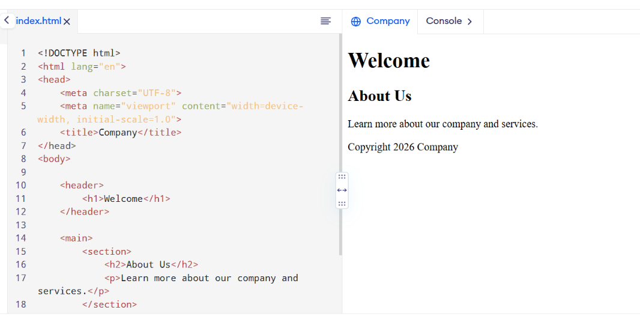

This structure uses valid nesting, properly closed tags, a DOCTYPE declaration, and appropriate semantic elements.

5. Suggest techniques to ensure cross-browser compatibility.

Validate HTML using the W3C Markup Validation Service.

Use standard HTML5 and CSS3 features.

Include a DOCTYPE declaration and viewport metadata.

Apply a CSS reset or consistent base styles where appropriate.

Test the webpage in Chrome, Firefox, Edge, and Safari.

Use responsive CSS and avoid browser-specific features unless necessary.

Test keyboard accessibility and different screen sizes.

Question 3: Form Submission Failure

1. Identify issues in the form configuration.

The given code is:

The button uses type="button", which does not submit the form by default.

The form uses the GET method, which places submitted values in the URL query string.

Sending a password using GET can expose sensitive information in browser history, logs, and URLs.

The input fields lack labels and required-field validation.

2. Analyze why the HTTP request is not triggered.

A button with type="button" does not trigger native form submission. Consequently, clicking it does not automatically send an HTTP request to /submit.

Changing it to type="submit" enables the browser to submit the form, provided validation succeeds.

3. Interpret the role of GET method in this scenario.

For example:

GET /submit?username=student&password=12345 HTTP/1.1

Host: example.com

This method is suitable for non-sensitive data and searches, but it is inappropriate for transmitting passwords because query parameters may be recorded in browser history, server logs, and other systems.

4. Propose a corrected implementation.

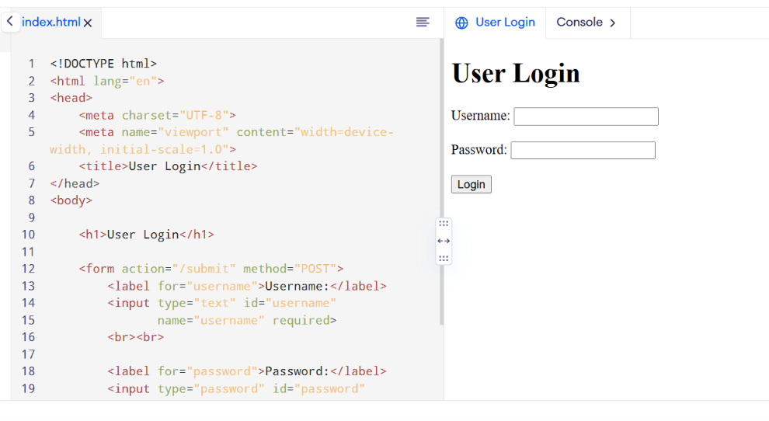

In this implementation, the POST method sends the form data in the request body, and the submit button triggers the form submission.

Criteria | Weig htage | Level 4 – Exemplary | Level 3 – Proficient | Level 2 – Developing | Level 1 – Beginning
Understanding of Concepts | 25% | Demonstrates thorough, accurate understanding of concepts | Good understanding with minor gaps | Basic understanding with some misconception  s | Poor understandin g; major misconceptio  ns
Explanation | 25% | Detailed, well-explained answers with  relevant examples | Clear explanation with adequate  details | Limited explanation; lacks depth | Poor or unclear explanation
Application | 20% | Effectively applies concepts with strong analytical ability | Applies concepts with minor errors | Limited application with weak  analysis | No application or incorrect  analysis
Organization | 15% | Well-structured answers with logical flow and coherence | Organized with minor issues in flow | Basic structure, lacks clarity | Poor organization, incoherent  answers
Accuracy | 10% | Completely accurate and covers all  required points | Mostly accurate with minor  omissions | Partially correct with  missing points | Incorrect answers with  major gaps
Clarity | 5% | Clear, neat, professional presentation | Understandable with minor issues | Limited clarity, readability issues | Poorly written, difficult to  understand

RUBRICS FOR CALCULATION:

